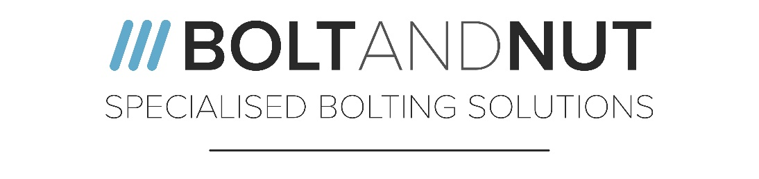

German Speaking Sales Executive - Well Established Fastener Company

Location: Wolverhampton, United Kingdom
Salary: Dependant on experience + Generous Benefits
Posted: 10/11/2021
Closes: 23/12/2021
Contract Type: Permanent, Full Time
Hours of Work: Monday – Friday 8am – 5pm
Website: www.bnml.co.uk

Bolt & Nut Manufacturing Ltd are recruiting for a German Speaking Sales Executive to join its sales team in a well-established fastener company. Specialising in the manufacture of fasteners for sectors such as oil & gas, petrol chemical and sub-sea. Our company has seen a substantial growth within recent years with healthy profits and investments in our staff and facility.
This role reports to the Sales Director and requires an experienced and highly driven individual to manage existing and new customer accounts. Individuals with experience within the fastener industry are preferred.
Applicants much have a passion and enthusiasm for sales and the products we manufacture. Applicants will need to be able to effectively manage their workload and meet strict deadlines. You will be required to use Microsoft Office and internal business systems.
If you feel you are suitable for the role, send your CV and cover letter via the recruitment page of the website stating the job role you are applying for. The successful applicant will be offered the role pending reference checks and eligibility to work in the United Kingdom. https://www.gov.uk/legal-right-work-uk
Bolt & Nut Manufacturing Ltd are committed to equal opportunities for all persons seeking employment with us. We will ensure no one receives less favourable treatment or will be disadvantaged by requirements or conditions that cannot be shown to be justifiable on the grounds of any protected characteristic.
Successful applicants will be contacted to determine if any special arrangements need to be made prior to the interview process.
Bolt and Nut Manufacturing Ltd
Cannon Business Park
Gough Road
Coseley
WV14 8XR
West Midlands, United Kingdom
www.bnml.co.uk
Tel: 01902 355 110

Job Title | German Speaking Sales Executive
Reporting | Sales Director
Bolt & Nut Manufacturing are looking to recruit a fluent speaking German Sales Executive to join the sales team and help support the growth of a well-established Manufacturing Company of Special Fasteners.

List of duties | - Handling existing and new customer accounts  - Work closely with other departments to help surpass the customers’ expectations  - Promote the business to build customer portfolio  - Proactive approach to the sale of products
Requirements (skills, experience, qualifications) | - Experience with fastener industry and exotic materials strongly preferred  - Good level of education and communication skills  - Excellent drive and determination  - Ability to work on one’s own initiative to achieve targets set  - Experience in Microsoft business packages  - Well presented
Personality type/traits/skills | - Fluent German language skills  - Good level of education  - Drive and determination  - Ability to work to deadlines  - Good time keeping  - Attention to details  - Ambitious
Salary | Generous salary and bonus package are offered with this role
Benefits (pension, healthcare, car) | Government pension scheme  Free Parking  Close to public transport links  Death in service benefit  Employee perk scheme offering rewards and money saving deals
Holidays | 24 days + bank holidays
Days and Hours | Monday – Friday 8am – 5pm
Dates free to interview: | Monday – Friday 8am – 5pm
Closing Date | 23/12/2021
Contact Details (name, number) | Lee Marsh – 01902 355110  lee.marsh@bnml.co.uk

